Project Title: Digital Naturalist Project Design Phase-I - Solution Fit Team ID: PNT2022TMID51330

- AI Enabled tool for Biodiversity Researchers

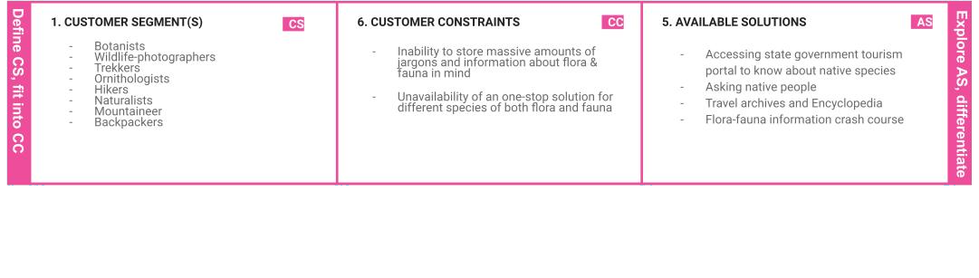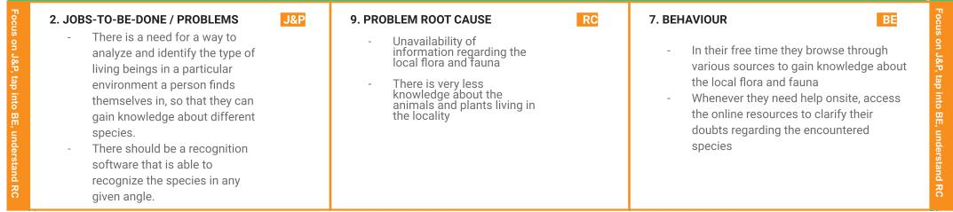

|  |  |  |  |  |
| --- | --- | --- | --- | --- |
|  | 1. **TRIGGERS TR**    * Unable to determine whether a   particular species of plant is poisonous or not while camping   * + Having trouble specifying the classof animals such as herbivore, carnivore, omnivore | **10. YOUR SOLUTION**  **SL**  The aim is to develop a recognition software using the concept of supervised learning that takes in the image of various species as the inputand provides the species name as output. | 1. **CHANNELS of BEHAVIOUR CH**    1. **ONLINE**       * Whenever they need help onsite, access the online resources to clarify their doubts regardingthe encountered species    2. **OFFLINE**       * In their free time they browse through various sources to gain knowledge about the local ﬂora and fauna |  |
| 1. **EMOTIONS: BEFORE / AFTER EM**    * Before:      + lost,      + Frustrated,      + & confused    * After:      + enlightened,      + Relieved,      + & confident |